**JAVA ASSIGNMENT-2**

**Database Tables Based On ER Diagram:**

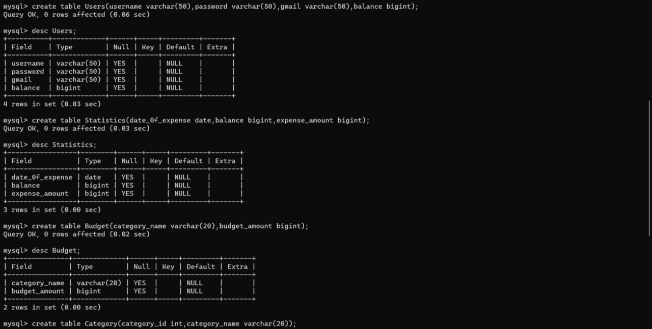

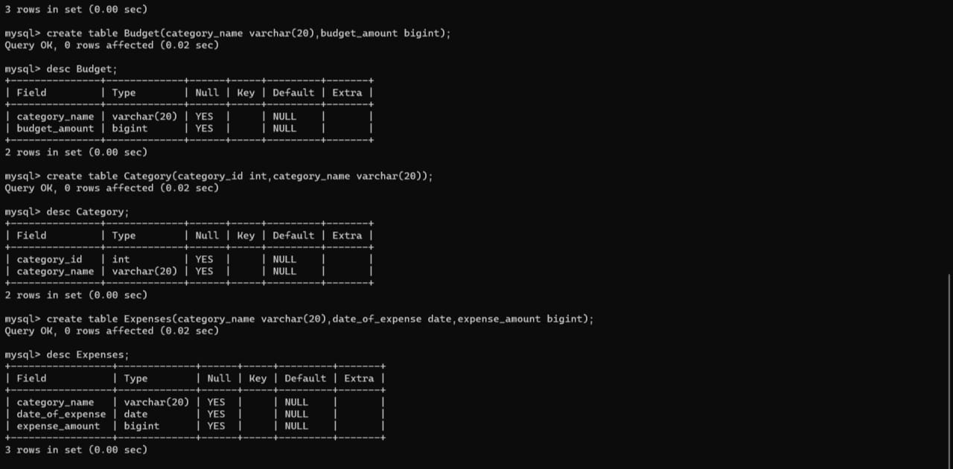

**Entity Relationship Diagram:**

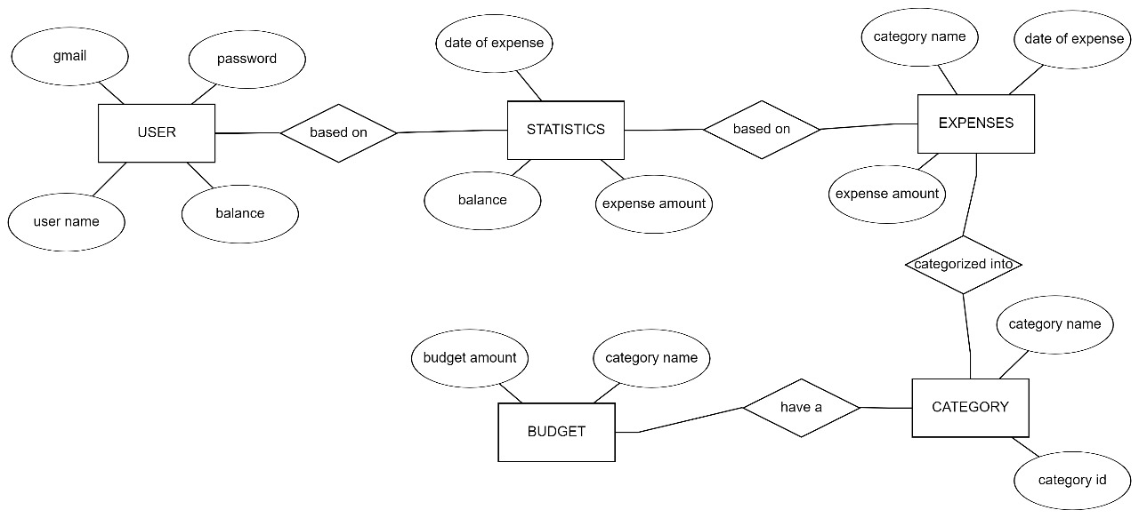

**Class Diagram:**

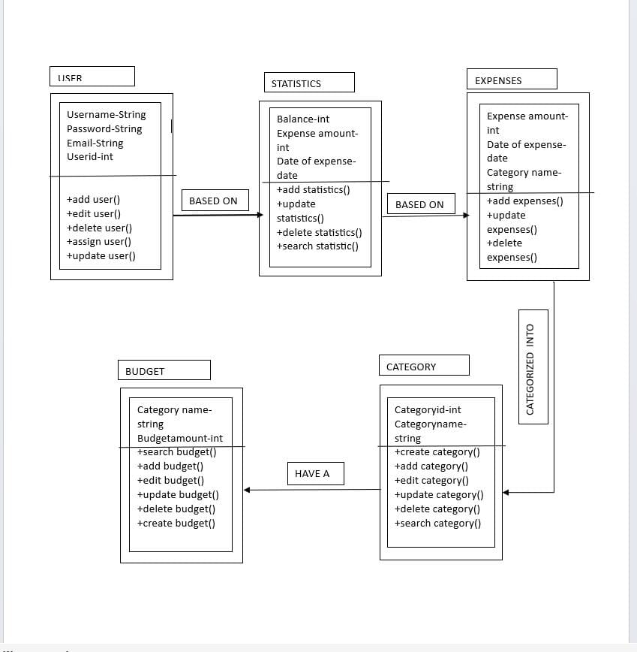

**User Diagram:**

